# Integration of Power Platform with Azure OpenAI Labs

## Overview

1. **Seamless Integration:** Azure Open AI provides seamless integration with Power Platform's low-code development environment, allowing users to easily incorporate AI capabilities into their applications and workflows. This integration eliminates the need for complex coding and enables users to enhance productivity by leveraging AI without extensive programming knowledge.
2. **Pre-built AI Models**: Azure Open AI offers a wide range of pre-built AI models that can be readily integrated into Power Platform applications. These models cover various domains such as natural language processing, image recognition, sentiment analysis, and more. By utilizing these pre-built models, users can quickly add advanced AI capabilities to their low-code applications, saving time and effort in developing AI algorithms from scratch.
3. **Custom AI Models:** In addition to pre-built models, Azure Open AI enables users to train and deploy their own custom AI models within the Power Platform environment. This empowers users to address specific business requirements and build AI solutions tailored to their unique needs. With low-code development and Azure's powerful AI capabilities, users can improve productivity by rapidly developing and deploying custom AI models without extensive coding expertise.
4. **Data Integration and Analysis:** Azure Open AI provides seamless data integration capabilities, allowing users to connect Power Platform applications with various data sources, both on-premises and in the cloud. This integration enables users to leverage AI algorithms to analyze and extract insights from large volumes of data, enhancing productivity by automating data processing tasks and generating valuable insights for decision-making.
5. **AI-Driven Automation:** With Azure Open AI and Power Platform's low-code capabilities, users can create intelligent workflows and automate repetitive tasks using AI algorithms. For example, they can build chatbots for customer support, automate document processing and analysis, or develop predictive models for forecasting. By automating these tasks, users can significantly improve productivity, streamline operations, and allocate resources more efficiently.

Overall, the combination of **Azure Open** AI and **Power Platform's low-code development environment** empowers users to **harness the power of AI to improve productivity**. Whether through pre-built models, custom AI development, data integration, or automation, this **integration offers a streamlined and efficient approach to incorporating AI capabilities** into applications and workflows.

## Prerequisites

### Azure OpenAI Prerequires

1. **Registration:** Begin by registering for Azure Open AI by visiting the following link: [Azure Open AI Registration](https://learn.microsoft.com/en-us/azure/cognitive-services/openai/overview). This registration process will provide you access to the Azure Open AI service.
2. **Resource Creation**: After your registration is approved, log in to the Azure portal and create an Azure Open AI resource. This resource will serve as the foundation for utilizing the Azure Open AI capabilities within your applications and workflows.
3. **Region Selection**: During the resource creation process, ensure that you select the US and Europe [**region**](https://learn.microsoft.com/en-us/azure/cognitive-services/openai/overview) as your preferred region. Choosing the correct region will ensure you have access to the desired AI capabilities. On **01 June 2023**, these regions are supported.
   1. East US
   2. South Central US
   3. West Europe
   4. France Central
4. **Resource Deployment:** Once the Azure Open AI resource is successfully created, proceed to create a deployment within the resource. This deployment allows you to configure and manage the specific AI models and services you want to utilize. You can customize the deployment based on your requirements and the specific AI capabilities you want to incorporate into your applications.
5. **Utilization and Integration:** With the deployment set up, you can now start utilizing the Azure Open AI services within your applications and workflows. This includes integrating the AI models, leveraging the available APIs and SDKs, and utilizing the AI capabilities to enhance productivity, automate tasks, and gain valuable insights from your data.

### Power Platform Requirements

1. **Power Platform Developer Plan**   
   Build and test Power Apps for free.   
   1. Free for development and testing  
      Create apps and flows without writing code with full-featured Power Apps and Power Automate development tools. Easily share and collaborate with others.
   2. Developer-friendly  
      Connect to data sources, including Azure, Dynamics 365, and custom APIs, with premium connectors. Create additional environments to exercise application lifecycle management and CI/CD
   3. Dataverse included.

Save time with a fully managed, scalable, Azure-backed data platform, including support for common business app actions. Use out-of-the-box common tables or easily build your own data schema.

* 1. Connect to data sources, including Azure, Dynamics 365, and custom APIs, with premium connectors. Create additional environments to exercise application lifecycle management and CI/CDcc

Cc

1. Power Apps pricing tiers  
     
   This is retail pricing [Pricing - Power Apps (microsoft.com)](https://powerapps.microsoft.com/en-us/pricing/)
2. Power Automate pricing tier  
     
   This is retail pricing [Pricing | Microsoft Power Automate](https://powerautomate.microsoft.com/en-us/pricing/)

## Azure OpenAI

### Scenarios

1. **Low-Code Development:** Building a **Power Apps** to create a demo or **personal knowledge** bot offers the advantage of a low-code development environment. Power Apps provides a visual interface with drag-and-drop functionality, making it accessible for users with varying levels of technical expertise. This empowers individuals without extensive coding knowledge to design and develop their own knowledge bots, reducing the reliance on dedicated development resources.

2. **Integration with Data Sources:** Power Apps allows you to seamlessly integrate with various data sources to enhance the functionality of your knowledge bot. You can connect your **Power App to Azure OpenAI service** and display relevant information. This integration enables your knowledge bot to provide accurate responses by pulling data from trusted sources, ensuring that users receive up-to-date and reliable information.

3. **User-Friendly Interface**: Power Apps enables you to design a user-friendly interface for your demo or personal knowledge bot. You can customize the look and feel of the app, including the **layout, colors, and branding, to create an engaging and visually appealing experience for your users**. With the ability to incorporate multimedia elements such as images, videos, and interactive controls, you can deliver a more interactive and immersive knowledge bot experience.

By leveraging the low-code development capabilities of Power Apps and its seamless integration with data sources, you can create a powerful and functional demo or personal knowledge bot. The user-friendly interface allows you to design an intuitive and visually appealing experience, ensuring that users can easily interact with the bot and access the information they need.

## Power Apps

* You will build a Power Apps canvas apps
* Use **different controls** such as
  + Text labels
  + Textbox
  + Buttons

* Wire up **Power Automate flow** as follows:   
    
  A screenshot of a computer

  Description automatically generated
* Select **Create from blank.**   
    
  A screenshot of a computer

  Description automatically generated
* Now our **Power Apps and Flow** are connected.   
    
  A screenshot of a computer

  Description automatically generated

## Power Automate

* In this lab, you will build a flow that uses Azure Open AI
* In **Next step**, search for **HTTP (Premium) connector**   
    
  A screenshot of a computer

  Description automatically generated
* Configure **HTTP action** as follows:   
  + Method: **Post**
  + URI: **Azure OpenAI endpoint**
  + Headers: **api-key** and **key from Azure OpenAI**
  + Body: Azure OpenAI reference to **add attributes  
      
    NOTES:   
    a) How to get Azure OpenAI Endpoint and api key?**   
    Completions >> Question answering >> View Code  
    A screenshot of a computer

    Description automatically generated with medium confidence  
      
    Copy endpoint and key at the **Copy** button  
      
    A screenshot of a computer program

    Description automatically generated with medium confidence  
      
    b) How to get structure for Power Automate HTTP Body attribute?   
    Reference: [Azure OpenAI Service REST API reference - Azure OpenAI | Microsoft Learn](https://learn.microsoft.com/en-us/azure/cognitive-services/openai/reference)  
    A screenshot of a computer

    Description automatically generated  
      
      
    A screenshot of a computer

    Description automatically generated  
      
    select **prompt** key within Body, select **Add dynamic content** and select Ask in **Power Apps**   
      
    A screenshot of a computer

    Description automatically generated
  + A screenshot of a computer

    Description automatically generated
  + Rename the flow **KnowledgeBotAzOpenAI**
  + **Next Action** is **Compose** action  
      
    A screenshot of a computer

    Description automatically generated with medium confidence
  + Under Inputs, select **Body**A screenshot of a computer

    Description automatically generatedA screenshot of a computer

    Description automatically generated with low confidence

* + Test the flow   
      
    A screenshot of a computer

    Description automatically generated with medium confidence  
      
    Select Manual testing  
      
    A picture containing text, screenshot, software, web page

    Description automatically generated
  + A picture containing text, screenshot, software, computer

    Description automatically generated
  + **Copy** the Compose content (JSON) to a text file
  + 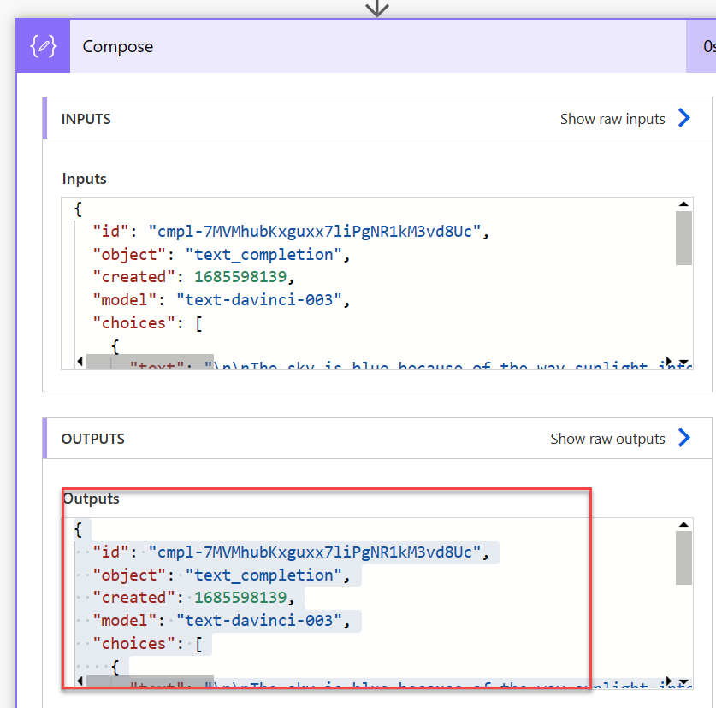
  + Next Step, you add a **Parse JSON** action   
    A screenshot of a computer

    Description automatically generated with medium confidence
  + Under **Content** select the **Body** object   
      
    A screenshot of a computer

    Description automatically generated  
    A screenshot of a computer

    Description automatically generated
  + Click on **Generate from Sample**  
      
    A screenshot of a computer

    Description automatically generated
  + Paste the **JSON content** that copied from above steps.  
       
    A screenshot of a computer

    Description automatically generated with medium confidence
  + Create a new variable   
    A screenshot of a computer

    Description automatically generated with medium confidence  
      
    A screenshot of a computer

    Description automatically generated with medium confidence
  + Next Action, you get **Apply for each loop**, extract **choices** and set a outsummary variable   
      
    A screenshot of a computer

    Description automatically generated  
      
      
    A screenshot of a computer

    Description automatically generated with medium confidence
  + Follow the same step that you did **Compose** message and extract the JSON content.   
      
    A screenshot of a computer

    Description automatically generated with medium confidence
  + Next Action will be **Respond to a Power App or Flow**  
      
    A screenshot of a computer

    Description automatically generated with medium confidence
  + A screenshot of a computer

    Description automatically generated with low confidence
  + A screenshot of a computer

    Description automatically generated
  + Save the Flow

## User Experience

* Attached Flow to Power Apps on the **Summarize Text**   
    
  A screenshot of a computer

  Description automatically generated

* Run the app
* A screenshot of a computer

  Description automatically generated
* SQL   
    
  A screenshot of a computer

  Description automatically generated

## References

1, **Azure OpenAI official documentation:** This is the official documentation provided by Microsoft Azure, offering detailed information, guides, tutorials, and examples on using Azure OpenAI.

- Documentation link: [Azure OpenAI Documentation](https://docs.microsoft.com/en-us/azure/openai/)

2. **Azure OpenAI Blog:** Stay updated with the latest news, announcements, case studies, and best practices related to Azure OpenAI through the official Azure Blog.

- Blog link: [Azure Blog - OpenAI](https://azure.microsoft.com/en-us/blog/topics/ai-openai/)

3. **Azure AI Developer Center:** This resource provides a comprehensive collection of documentation, samples, SDKs, and tools for AI development on Azure, including OpenAI.

- Developer Center link: [Azure AI Developer Center](https://azure.microsoft.com/en-us/developers/ai/)

4**. Microsoft Learn:** Microsoft Learn offers free, interactive, and hands-on learning modules and courses to help you understand and implement Azure OpenAI effectively.

- Microsoft Learn link: [Azure OpenAI on Microsoft Learn](https://docs.microsoft.com/en-us/learn/azure/openai/)

5. **Azure AI Gallery:** Explore a wide range of AI solutions and examples created by the community and Microsoft experts on the Azure AI Gallery. You can find sample projects and resources related to Azure OpenAI.

- Azure AI Gallery link: [Azure AI Gallery](https://gallery.azure.ai/)

These references should provide you with a solid foundation and valuable resources to explore Azure OpenAI and its integration with various Azure services.